LOCALIZATION IN WIRLESS SENSOR NETWORKS USING REACH CENTROID ALGORITHM
vazralu.M¹, Associate Professor, Novy Jacob² Assistant Professor
¹Department of Information technology, Malla Reddy College of Engineering & Technology, Secunderabad-500 100, Telangana State, India. mvazralu1206@gmail.com
2Department of Information technology, Malla Reddy College of Engineering & Technology, Secunderabad-500 100, Telangana State, India. novyjacob@gmail.com
ABSTRACT
Position and accurate is the important for the localization in wireless sensor networks. This technique it the low cost technique in wireless sensor networks.. to manage the cost and ,few location aware node, it is called as anchors in wireless sensor networks environment. Other anchors of free node estimate the own positions. If you have change the any position of the node or modify from centroid localization algorithm called as reach centroid localization algorithm. This method mainly focus on anchor nodes position validation methods. Every anchor node with the near free node search and validate the position of actual or near node will received the signal strength . This work reduce the multipath effects of radio waves, particularly enclosed the environment.our proposed work is localization become more significant, particularly indoor environments, the result show a siginificant improvement in localization accuracy when compare with the original centroid localization algorithm.
Keyword: WSN, Centroid, Localization

INTRODUCTION
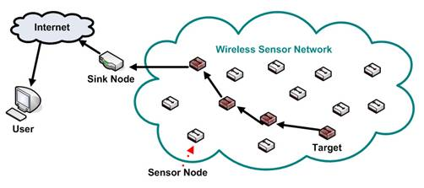
Wireless sensor networks (WSN), are similar to wireless ad hoc networks in the sense that they rely on wireless connectivity and spontaneous formation of networks so that sensor data can be transported wirelessly. Sometimes they are called dust networks, referring to minute sensors as small as dust. Smart dust [1][2][3] is a U C Berkeley project sponsored by DARPA. Networking. Is one of the early companies that produced wireless sensor network products. WSNs are spatially distributed autonomous sensors to monitor physical or environmental conditions, such as temperature, sound, pressure, etc. and to cooperatively pass their data through the network to other locations.[4] The more modern networks are bi-directional, also enabling control of sensor activity. The development of wireless sensor networks was motivated by military applications such as battlefield surveillance; today such networks are used in many industrial and consumer applications, such as industrial process monitoring and control, machine health monitoring, and so on.

Fig1: Wireless sensor Networks

ALGORITHM DEVELOPMENT
In this section, we are going to derive a novel node localization method for 3D WSNs. Before proceeding, we review the centroid algorithm. 2.1 Review of Centroid Algorithm Bulusu and Heidemann [2] have proposed the centroid localization algorithm, which is a range-free, proximity-based, coarse-grained localization algorithm. The algorithm implementation contains three core steps. First, all anchors send their positions to all sensor nodes within their transmission range. Each unknown node listens for a fixed time period t and collects all the beacon signals it receives from various reference points. Second, all unknown sensor nodes calculate their own positions by a centroid determination from all n positions of the anchors in range. The centroid localization algorithm, which uses anchor nodes (reference nodes), containing location information ( , ) i i x y , to estimate node position. After receiving these beacons, a node estimates its location using the following centroid formula:
RANGE-FREE ALGORITHMS
The nature of radio wave propagation is such that the attenuation of radio signal increases as distance between the transmitter and receiver increases. Radio propagation models [11] in various environments are well documented and have often focused on estimating the average Received Signal Strength (RSS) at a particular distance of the transmitter, as well as the variability of the signal strength in close spatial proximity to the location.
The Departure Test Definition shows that when incrementally increasing the distance between anchors and receiving nodes, the RSS monolithically decreases with distance [8]. However, there are instances where there are burst in signal strength due to disturbance effects, such as, reflection leading to signal amplification or sudden loss of signal, due to absorption as a result of environmental conditions. Nevertheless, the test does not make any assumption about the correlation between absolute distance and signal strength.
Relevant to our research are some Range-free algorithms such as DV-hop, Amorphous, APIT and CLA algorithms. This is because these algorithms operate on the same fundamental principle; they all attempt to select the anchors with the most significant characteristics for location estimation. These algorithms will be briefly discussed.
DV-HOP AND AMORPHOUS ALGORITHMS
DV-Hop and Amorphous algorithms both use a form of distance vector exchange so that all the nodes within the network get estimated distances in hops to the anchors [12] as against the linear distance between the free node and the anchor. A node estimates its position by assuming the average distance of the closest anchor to it. It then uses the distance in hop count to estimate its position from at least two other anchors using the same distance average received from the anchor closest to it. After which, triangulation is performed to estimate the position of the free node. This procedure is appropriate for nodes with limited capabilities and lacks the ability to process the image of the entire network.
REACH CENTROID LOCALIZATION ALGORITHM
he relationship between transmitted and received signal is not symmetric. Two nodes transmitting and receiving signals between each other are likely not to receive each other’s signal at the same strength even if their power of transmission is the same. Many factors such as multipath effects account for this discrepancy. This situation or condition often leads to the erroneous localization of objects, particularly indoors. ReachCLA seeks to manage these conditions towards a more reliable estimation of the position of objects.
The algorithm establishes an authentication or feedback process between the free node and the anchors within its reach. In a global WSN environment, a free node is likely to receive signals from anchors within its immediate locality. These anchors are the ones within its reach and they are the ones that will participate in the localization process. ReachCLA [9] has five main phases, they are summarized as follows:
The free node selects all the anchors that are within its reach.
The second phase is the feedback or handshake phase[6]. This is to establish how the anchors read each other. This process is key as it allows the anchors establish their proximity to one another, and by so doing, they are able to reasonably ascertain the true position of the free node.
Selection of the anchors with the strongest reach. This is done as each selected anchor by the free node compare the anchors within their reach to other anchors selected by the free node.
Selection of the anchors with the three highest links or reach. Selection is from the group of anchors within the range of the free nodes, these are the anchors that have more anchors in common when matched with the anchors within the reach of the free node.
There are probable instances where an anchor within the reach of a free node will not be able to read the transmitted signal from the free node in a two way communication. However, because the anchor in case is able to communicate with other anchors that are within the reach of the free node, it therefore assures the likelihood or authenticates that the free node is within its own proximity. It is this authentication process that makes ReachCLA a unique and reliable algorithm for localization. An experimental testbed was set up to analyse the performance of ReachCLA alongside CLA and APIT algorithms
FINDINGS AND DISCUSSION
The simulations of ReachCLA, CLA and APIT algorithms respectively. The simulations show the different estimated positions of the sensor node using each algorithm. presents the various estimated locations of the sensor node using ReachCLA, CLA and APIT on a single plot[13]. The various plots indicate that the fundamental principle of ReachCLA is similar to that of CLA and APIT as they all embrace the formation of triangles within areas of discernible radio signal, and use the triangles to estimate the location of the intended object. However, the main distinction lies in the process of selecting the most likely triangle or triangles to be used for localization. This is where ReachCLA, as indicated in Table 3, outperforms both CLA and APIT.
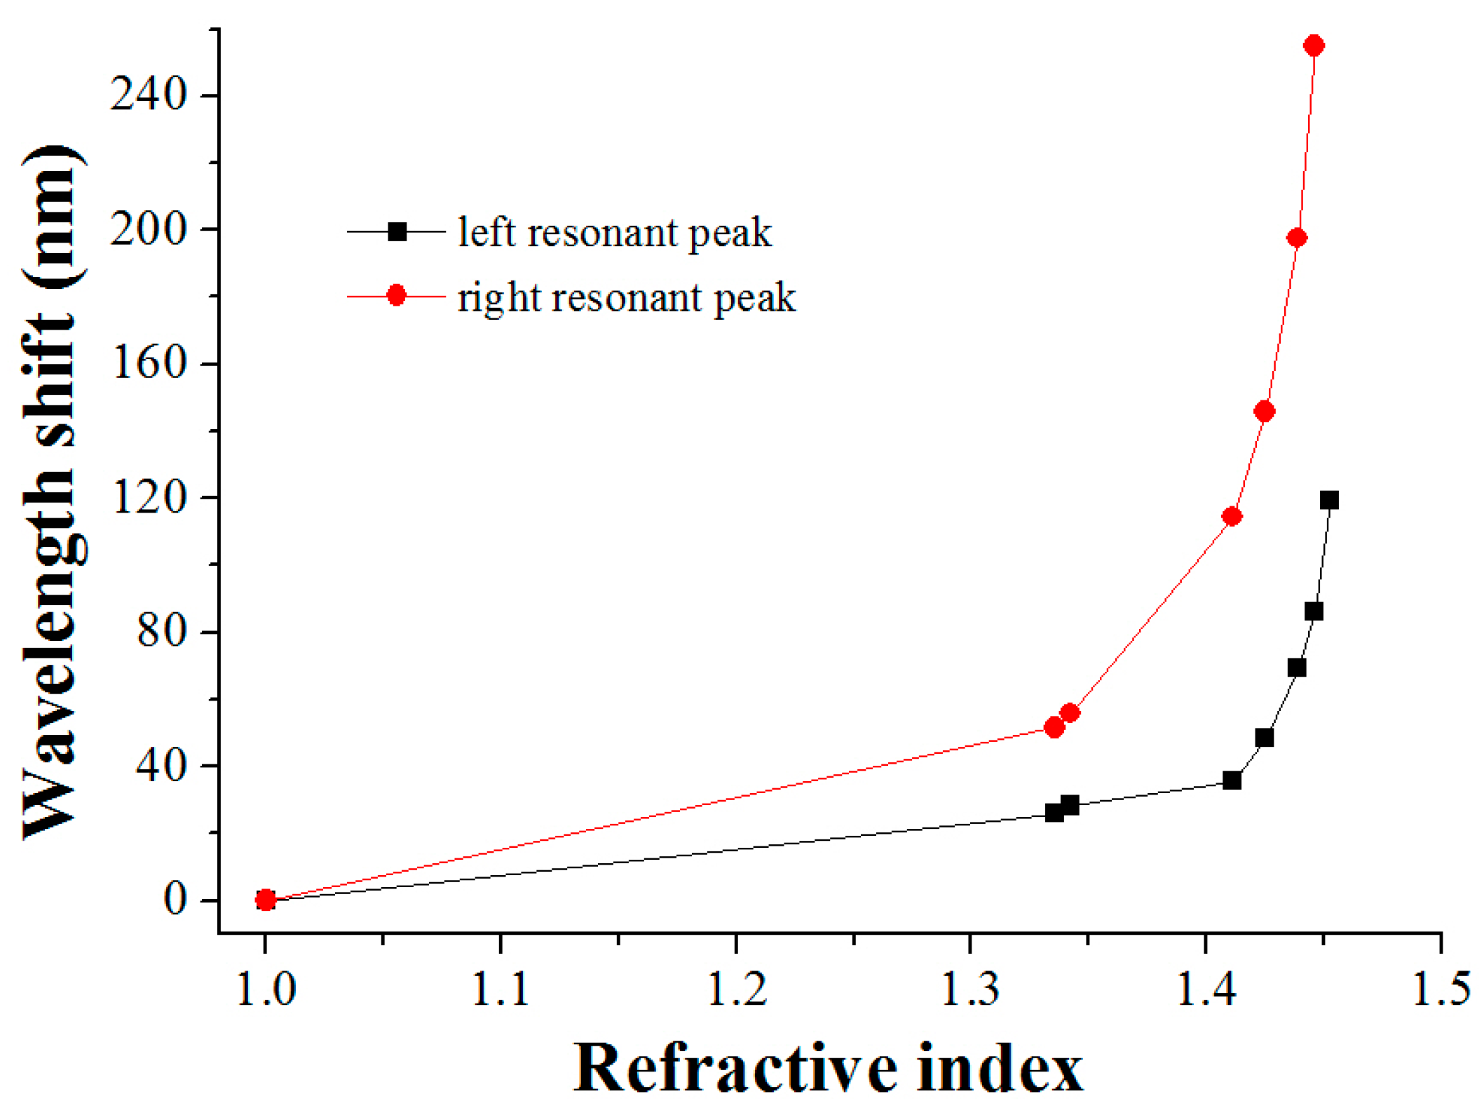

Fig: Comparison Graph for Left Peak & Right Peak
CONCLUSION
We present a new localization method that improves the basic centroid localization algorithm significantly. It is shown in the simulation results that the proposed algorithm can improve location accuracy than the conventional centroid localization algorithm. The performance of our proposed scheme has identified that it has potential application advantage of centroid algorithm [3].
REFERENCES
[1]. Sharma, R. and Malhotra, S. (2015) Approximate Point in Triangulation (Apit) Based Localization Algorithm in Wireless Sensor Network. International Journal for Innovative Research in Science and Technology, 2, 39-42. [Citation Time(s):1]
[2]. He, T., Huang, C., Blum, B.M., Stankovic, J.A. and Abdelzaher, T. (2003) Range-Free Localization Schemes for Large Scale Sensor Networks. Proceedings of the 9th Annual International Conference on Mobile Computing and Networking, San Diego, 14-19 September 2003,81-95.
[3].Dargie, W. and Poellabauer, C. (2010) Fundamentals of Wireless Sensor Networks: Theory and Practice. John Wiley & Sons, Hoboken.
[4]. Kumar, A., Kumar, V. and Kapoor, V. (2011) Range Free Localization Schemes for Wireless Sensor Networks. 10th WSEAS International Conference on Software Engineering, Cambridge, 22-24 February 2011, 101-106.
[5]. Karl, H. and Willig, A. (2007) Protocols and Architectures for Wireless Sensor Networks. John Wiley & Sons, Hoboken.
[6]. Kim, S.-Y. and Kwon, O.-H. (2005) Location Estimation Based on Edge Weights in Wireless Sensor Networks. The Journal of Korean Institute of Communications and Information Sciences, 30, 938-948
[7]. Chong, C. and Kumar, S.P. (2003) Sensor Networks: Evolution, Opportunities, and Challenges. Proceedings of the IEEE, 91, 1247-1256.
[8]. Li, X.-Y., Wan, P.-J. and Frieder, O. (2003) Coverage in Wireless Ad Hoc Sensor Networks. IEEE Transactions on Computers, 52, 753-763.
[9]. Lazos, L. and Poovendran, R. (2004) Serloc: Secure Range-Independent Localization for Wireless Sensor Networks. Proceedings of the 3rd ACM Workshop on Wireless Security, Philadelphia, 01 October 2004, 21-30.
[10]. Nagpal, R., Shrobe, H. and Bachrach, J. (2003) Organizing a Global Coordinate System from Local Information on an Ad Hoc Sensor Network. In: Zhao, F. and Guibas, L., Eds., Information Processing in Sensor Networks, Springer, Berlin, 333-348.
[11]. Priyantha, N.B., Chakraborty, A. and Balakrishnan, H. (2000) The Cricket Location-Support System. Proceedings of the 6th Annual International Conference on Mobile Computing and Networking, Boston, 06-11 August 2000, 32-43.
[12]. Bulusu, N., Heidemann, J. and Estrin, D. (2000) Gps-Less Low-Cost Outdoor Localization for Very Small Devices. IEEE Personal Communications, 7, 28-34.
[13]. Long, S., Wang, F., Duan, W. and Ren, F. (2004) Range-Free Self-Localization Mechanism and Algorithm for Wireless Sensor Networks. Computer Engineering and Applications, 23, 39.
[14]. He, T., Huang, C., Blum, B.M., Stankovic, J.A. and Abdelzaher, T.F. (2005) Range-Free Localization and Its Impact on Large Scale Sensor Networks. ACM Transactions on Embedded Computing Systems, 4, 877-906
[15]. Rappaport, T.S. (1996) Wireless Communications: Principles and Practice. Vol. 2, Prentice Hall, Upper Saddle River.

